Internet of Things

MODULE 1

Overview of IoT:

Overview of Wireless Sensor Networks,

Overview of Internet of Things,

IoT Conceptual Framework,

IoT Architectural View,

Technology Behind IoT,

Sources of IoT,

M2M Communication.

Design Principles:

IoT/M2M Systems Layers and Design Standardization, Communication Technologies,

Data Enrichment, Data Consolidation and Device Management at Gateway,

Eg of IoT,

Ease of Designing and Affordability

Internet of Things

Internetwork of Things,

(that enable things to communicate as if they are computing unit)

(wherein things embedded with electronics, hardware, communication)

so that they can be monitored, controlled, coordinated with other devices

IOT is a concept which enables communication between internetworking devices and applications, whereby physical objects (‘things’) communicate through the Internet

Earliest IOT: RFID (Radio Frequency Identification Device)

Vision of IoT

- Things becoming smart/intelligent and behaving alive

- Smart, Hyperconnectivity

CONCEPTUAL FRAMEWORK
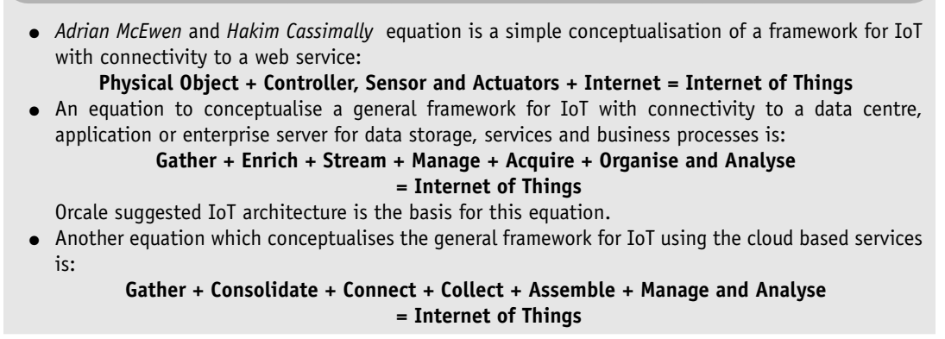
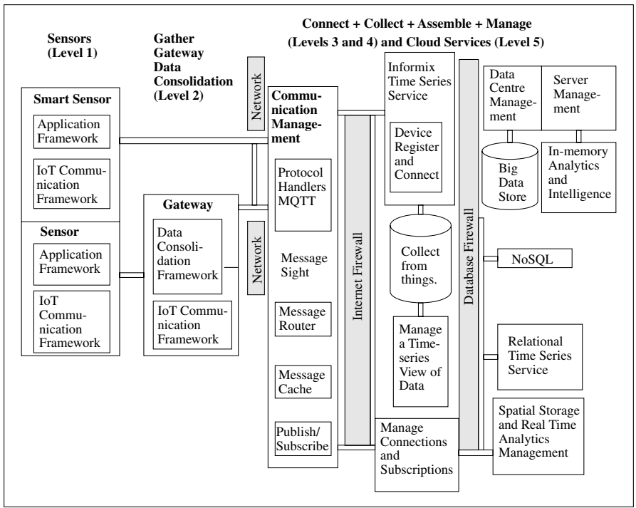

(IBM)

ARCHITECTURAL VIEW

(Cisco 7 levelled view)
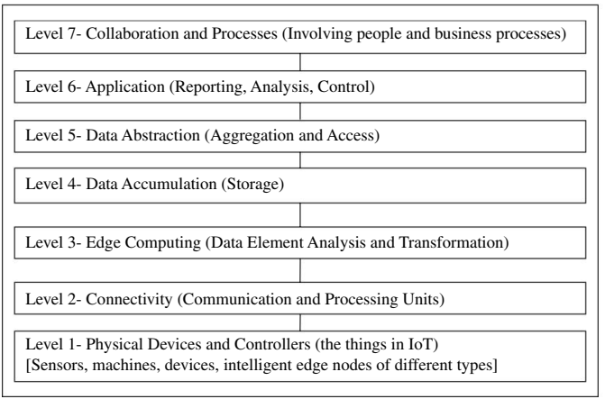

REFERENCE MODEL

(Oracle)
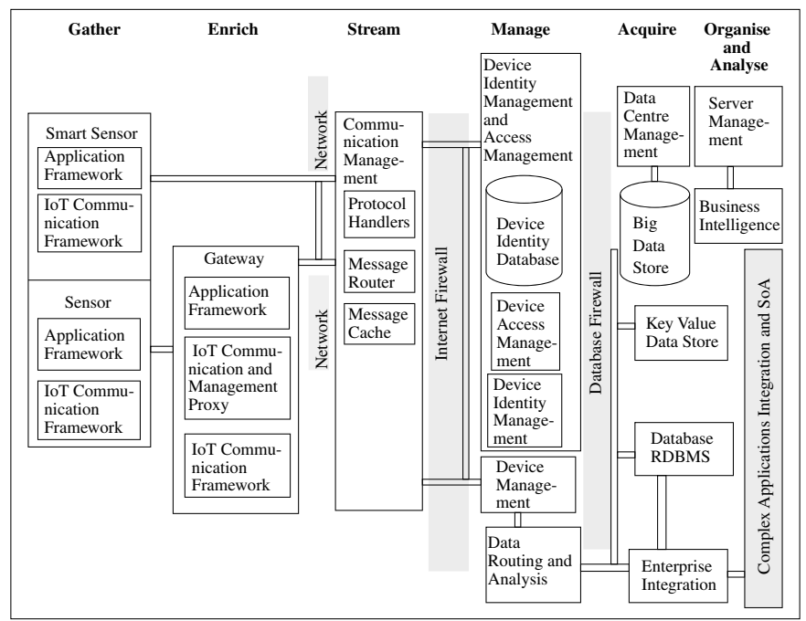

TECHNOLOGY Behind IOT
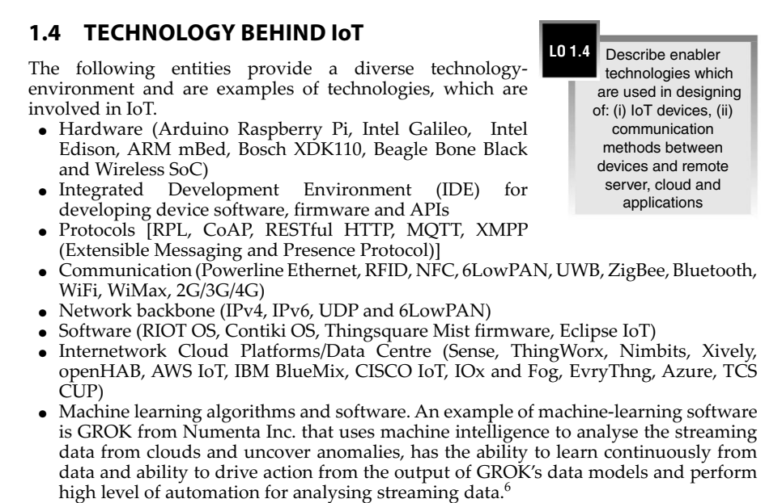

Major Components of IOT System
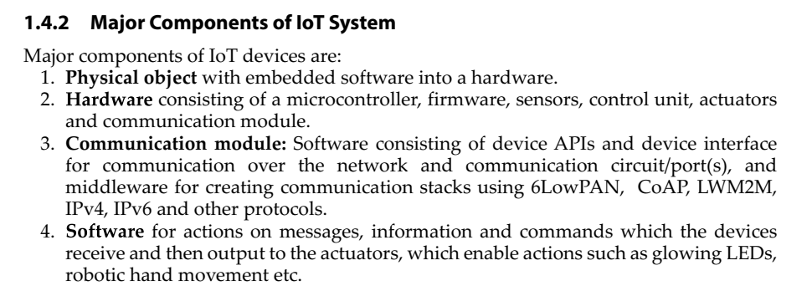

SOURCES of IOT

M2M Communication
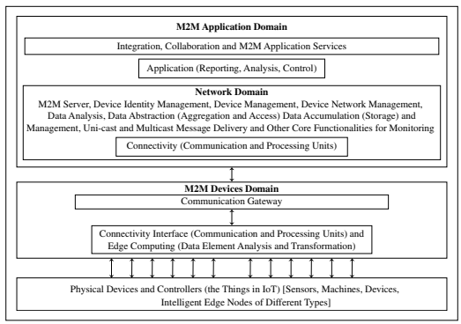

UNIT 2:

Machine-to-Machine Communication;

Message Communication Protocols: Message Queue Telemetry Transport ( MQTT)

UNIT 3:

Internet of Things Privacy, Security and Governance-Introduction, Overview of Activity Chain Governance,

Privacy and Security Issues,

Contribution From FP7 Project,

Security and Privacy Challenge in Data Aggregation for the IoT in Smart Cities-Security,

Privacy and Trust in Iot-Data Platforms for Smart Cities,

First Steps Towards a Secure Platform,

Smartie Approach

FP7 iCore Access Framework (iCore Contribution)

IoT@Work Capability Based Access Control System (IoT@Work Contribution)

MQTT (Message Queueing Telemetry Transport)

